Session 4 – Motivation

1. What is Motivation?
Motivation is the internal or external drive that pushes individuals to take action, pursue goals, overcome challenges, and achieve success.
In a work context:
Motivation is an individual’s willingness to exert and maintain effort toward organizational goals. It’s fueled by a mix of personal needs, values, and external factors.

2. Types of Motivation
Type | What It Is | Examples
Intrinsic Motivation | Driven by internal rewards—personal satisfaction, interest, or enjoyment. | Pride in a project, learning a new skill, sense of accomplishment.
Extrinsic Motivation | Driven by external rewards or avoiding punishment. | Salary, bonuses, promotions, awards, fear of criticism.
Key Insight:
While both are important, intrinsic motivation tends to lead to longer-lasting engagement and satisfaction.

3. Why Motivation Matters
For You:
- 🎯 Provides clear goals and direction
- 💪 Helps overcome procrastination and obstacles
- 🧠 Encourages problem-solving and adaptability
- 📈 Increases resilience in the face of setbacks
For Organizations:
- 🚀 Boosts productivity and performance
- 🤝 Improves teamwork and morale
- 🌱 Fosters innovation and commitment
- 📊 Enhances employee retention and satisfaction

4. Theories of Motivation
Maslow’s Hierarchy of Human Needs
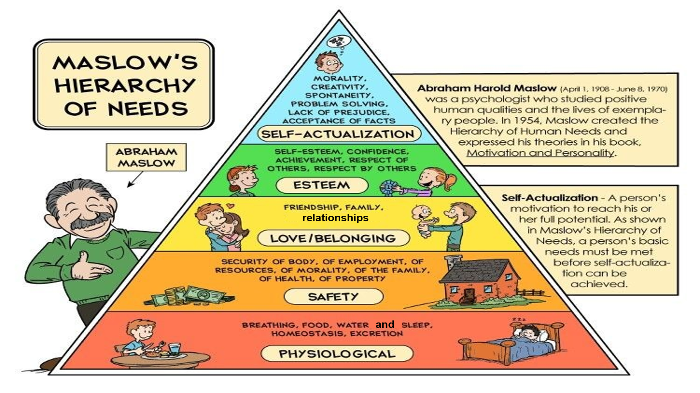
Herzberg’s Two-Factor Theory
- Hygiene Factors: Elements that prevent dissatisfaction (e.g., salary, job security, work conditions).
- Motivators: Elements that increase satisfaction and motivation (e.g., recognition, growth, responsibility).
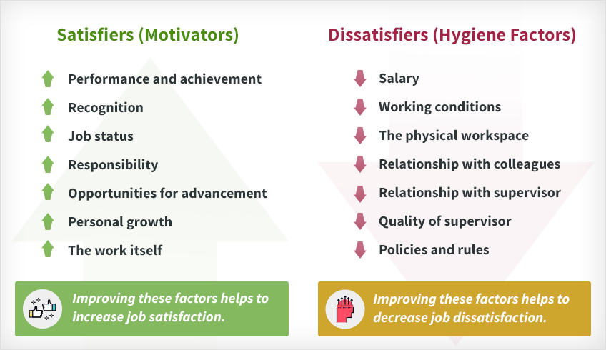
Takeaway: To truly motivate employees, focus on motivators, not just hygiene factors.

5. Self-Motivation as an Emotional Intelligence Skill
Self-motivation is a core component of self-management in emotional intelligence. It enables you to:
- Stay focused and disciplined without external pressure
- Bounce back from failures with enthusiasm
- Align daily tasks with long-term goals
- Inspire and positively influence others through your drive
Without self-motivation, even clear goals and rewards may not sustain effort.

6. What Demotivates People at Work?
- Lack of recognition or feedback
- Unclear goals or expectations
- Poor communication or leadership
- Micromanagement
- Unfair treatment or favoritism
- Lack of growth opportunities
- Toxic work environment

7. How to Motivate Yourself: Practical Strategies
Strategy | How to Apply It
Have a Vision | Picture your long-term goals—make them inspiring and clear.
Set Specific Goals | Break your vision into actionable, measurable steps.
Create Habit Triggers | Use timers, reminders, or rituals to start tasks.
Prioritize Well-Being | Get enough sleep, exercise, and downtime.
Do Something You Enjoy | Integrate hobbies or interests into your routine.
Avoid Negative Influences | Limit time with pessimistic people or environments.
Take Action—Any Action | Start small to build momentum.
Maintain Perspective | Reflect on past successes and gratitude during tough times.

8. Recognition & Reward Systems in the Workplace
Effective recognition boosts motivation, loyalty, and performance.
Elements of a Good Recognition Program:
- Clear criteria (what behaviors are rewarded)
- Timely and specific feedback
- Mix of intrinsic and extrinsic rewards
- Inclusivity (individual and team recognition)
- Consistency and fairness
Recognition Ideas:
- Employee of the Month
- Peer-to-peer awards
- Milestone celebrations
- Learning and development opportunities
- Flexible work options
- Public praise in meetings or newsletters

9. Summary
Motivation is the engine behind personal and professional achievement. By understanding what drives you (and others), you can design a work life that is not only productive but also fulfilling. Whether through intrinsic passion, extrinsic rewards, or supportive recognition systems, sustained motivation is key to growth, resilience, and success.
Remember: Motivation isn’t a constant state—it’s a skill you cultivate daily through habits, mindset, and supportive environments.

